My Organizer – AC#11

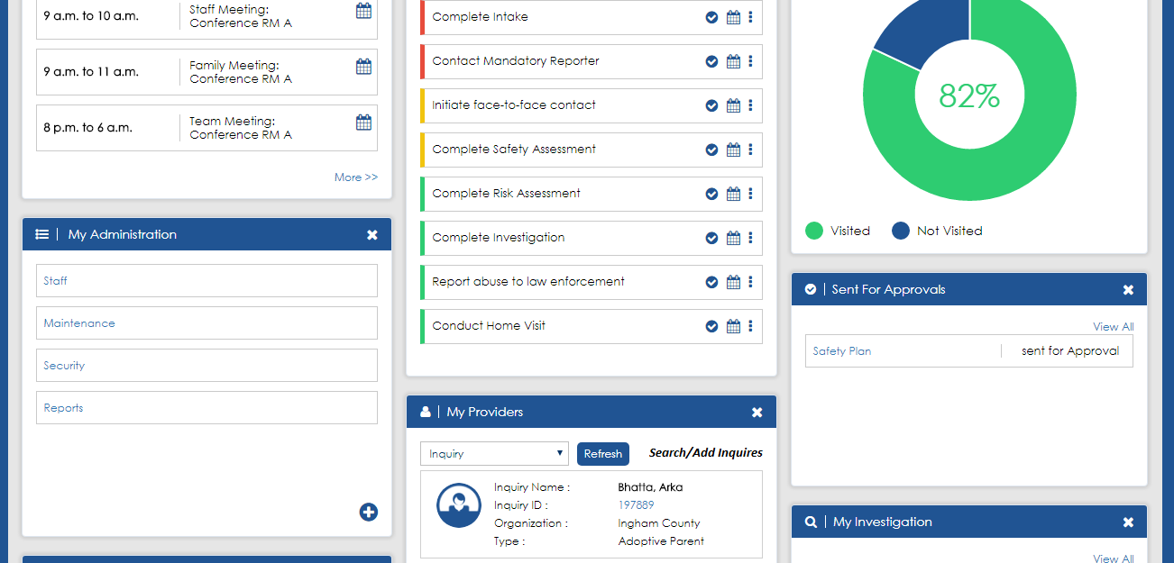

Acceptance Criteria#1 & 7: Side bar & New Section

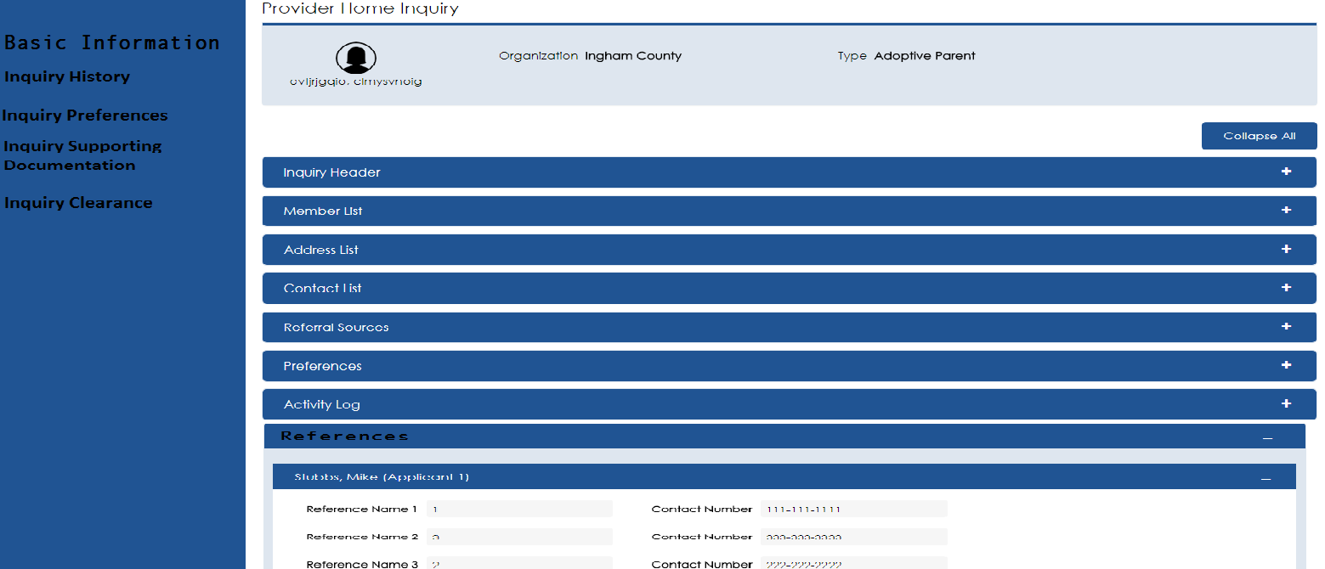

Only the screen that I am currently on should have a darker blue in the left hand navigation.

Acceptance Criteria#3,

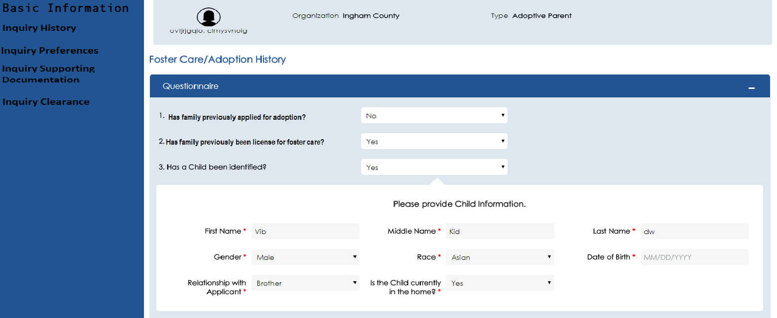

Acceptance Criteria#4

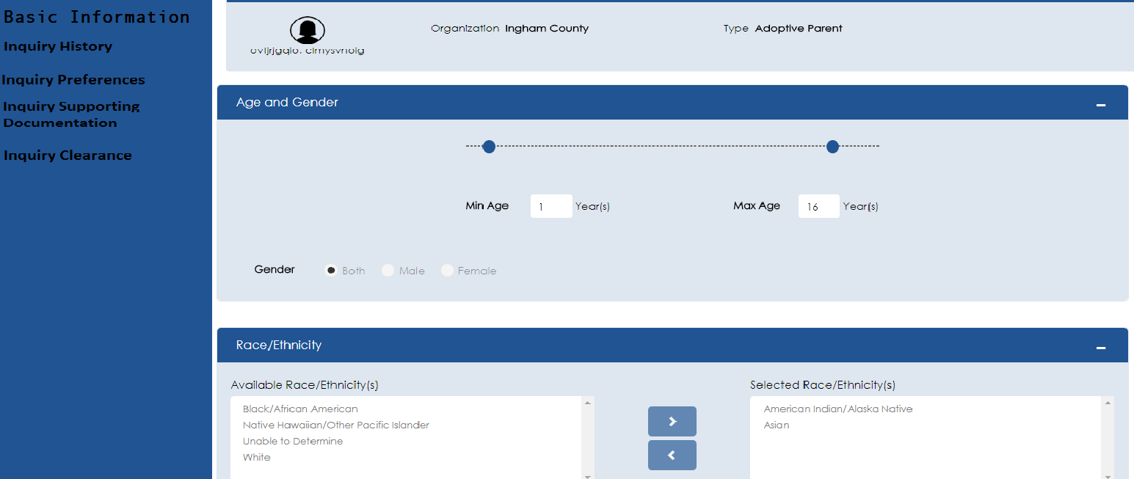

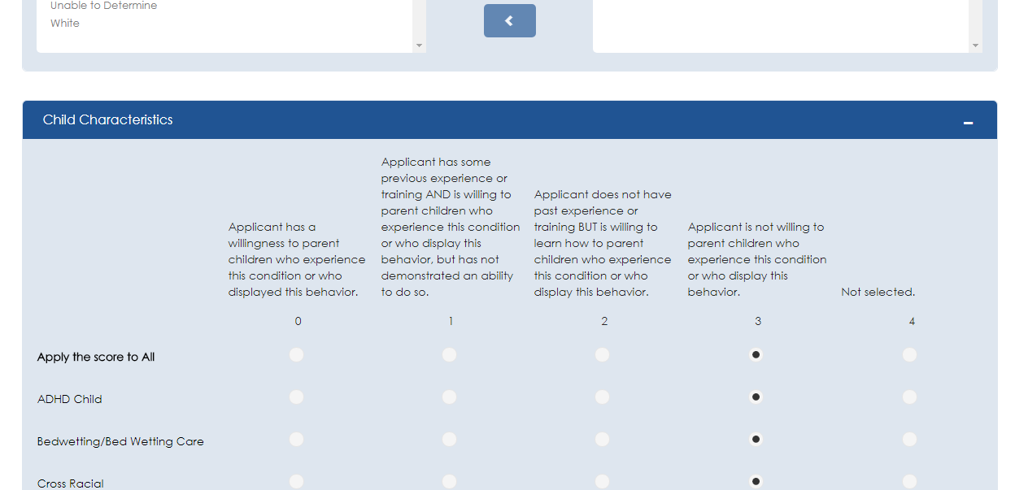

Acceptance Criteria#

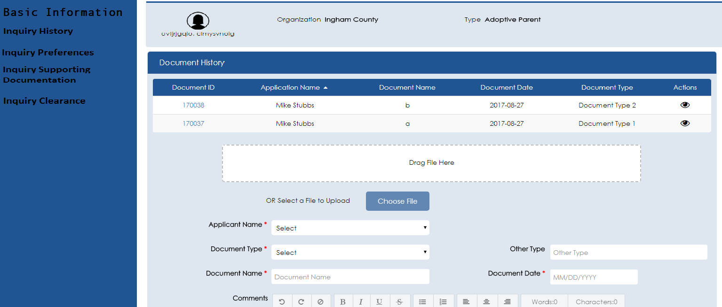

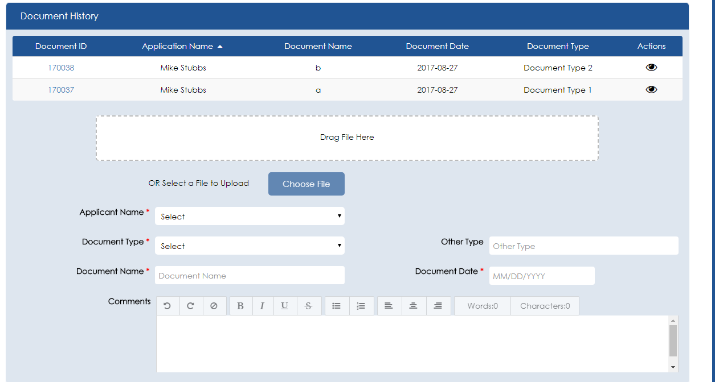

AC#6

